**Software pipelines for users**

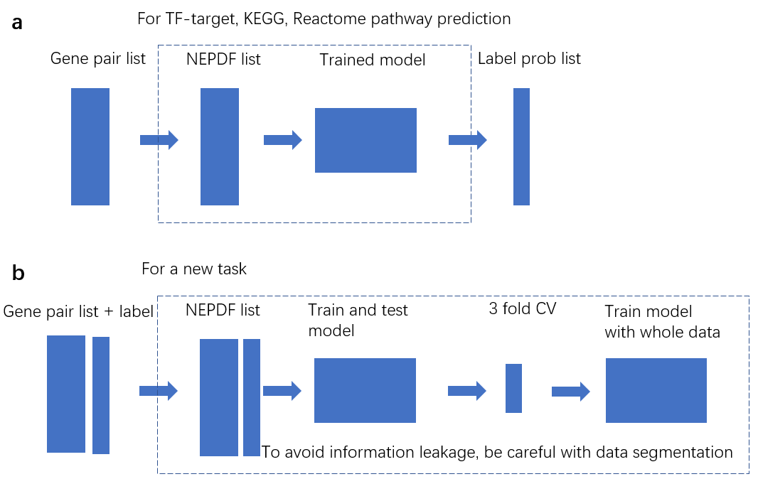 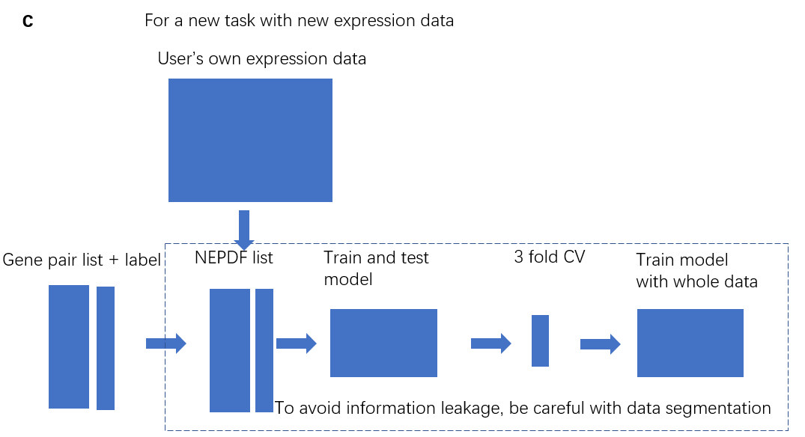

(**a**) Pipeline for TF-target, KEGG and Reactome edge predictions. Users only need to provide gene-pair candidate list. (**b**) Pipeline for a new task with the expression data we collected. Users need to provide gene-pair candidate list to generate NEPDF list and label list to train and test model. (**c**) Pipeline for a new task with the expression data users collect. Users need to provide gene-pair candidate list, their own expression data to generate NEPDF list, and label list to train and test model.